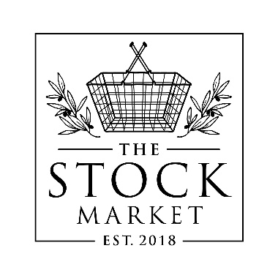

Old Fashion Challenge

*Be Shawano County’s #1 Mixologist*

**Sponsored by: The Stock Market, Shawano**

***When : Monday, September 2, 2024***

***Check in Time : 1:00, mixing starts at 1:30pm***

***Where: On the Midway Stage***

***Entry Fee: $10.00***

***Special Note:***Mixologists must bring all their supplies (including Alcohol) with them at Check-in. **Shawano Fair will supply Pint Glasses, Stir sticks, Ice, and poke stick for garnish.** The Mixologists will mix their Old Fashions, 1 contestant at a time, in front of our 3 judges, before they taste test it. We will separate Whiskey and Brandy. Sweet and Sour for taste testing, so please fill entry out in full so we can arrange this.

Steeped in tradition and muddled with intoxicating flavors, this contest will redefine the iconic Wisconsin Cocktail. The history of the Old Fashion Dates back to the 1800’s, but now its your chance to redefine this Shawano County Tradition. Brandy or Whiskey can be used. So put your personal spin on this Iconic Wisconsin Drink and see if you have what it takes to be Shawano County’s #1 Mixologist.

This Contest is limited to adults ages 21 and older. We will be taking the first 12 entrants.

***Payout in both Categories: Amateur and Professional***

***Stock Market Gift Certificate***

***1st - $75.00 2nd - $50.00 3rd - $25.00***

***Contestants will be scored on 100 point system by each judge.***

***Taste : 40 points -- Appearance : 35 points -- Creativity/Originality : 25 points***

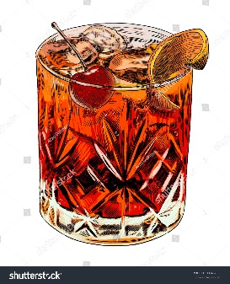

NAME______________________________________

ADDRESS__________________________________

PHONE NUMBER ___________________________

WHISKEY OR BRANDY_______________________

WASH (SWEET, SOUR)_______________________

Amateur _________________________________

Professional where? ________________________